Step 1: Installation of VB box and cloudera

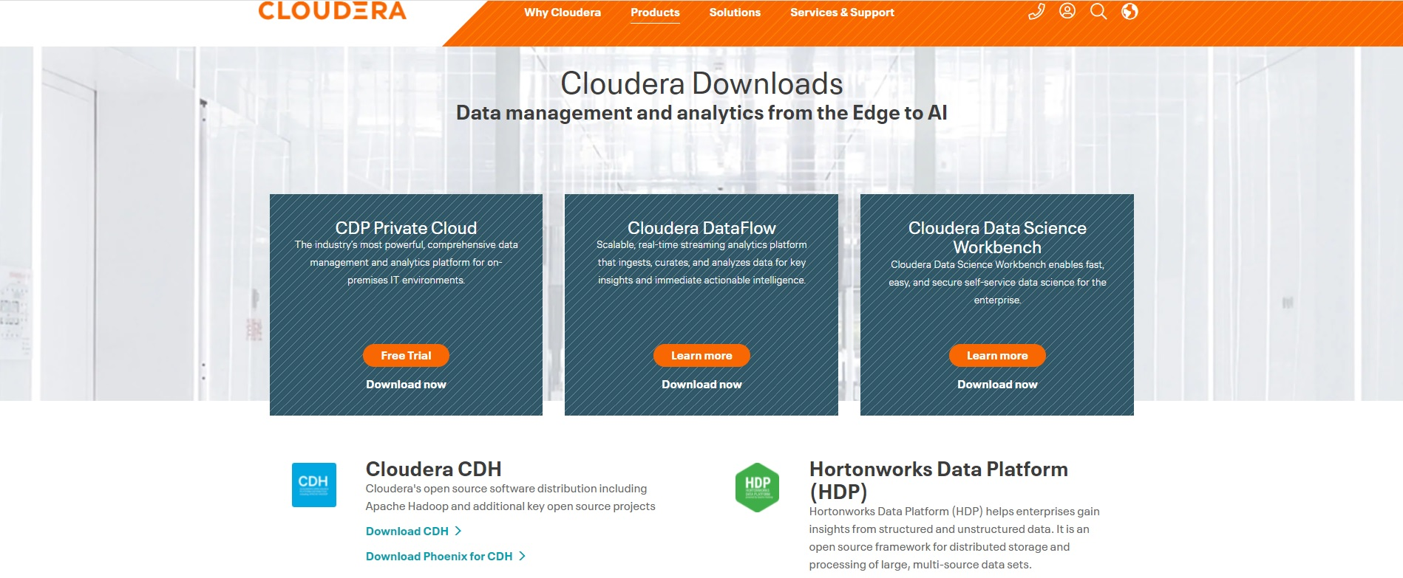

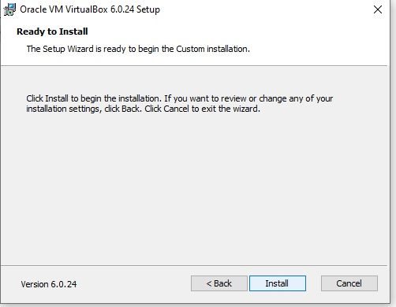

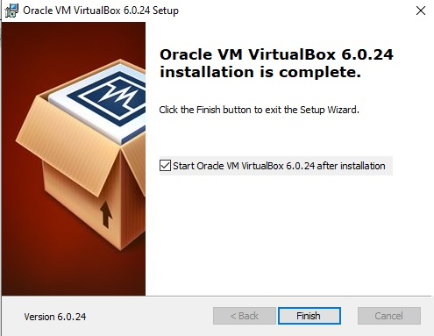

Step 4: Select File

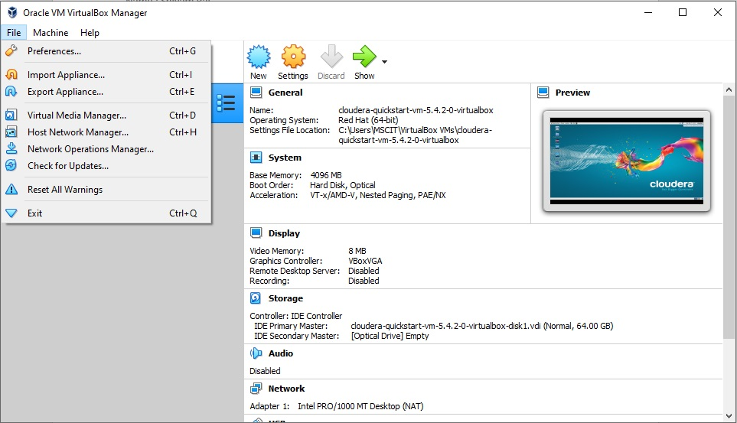

Step 5: Select Import Appliances

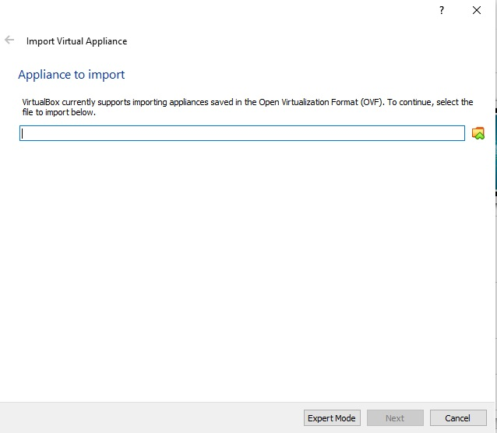

Step 6: Select OVF File:

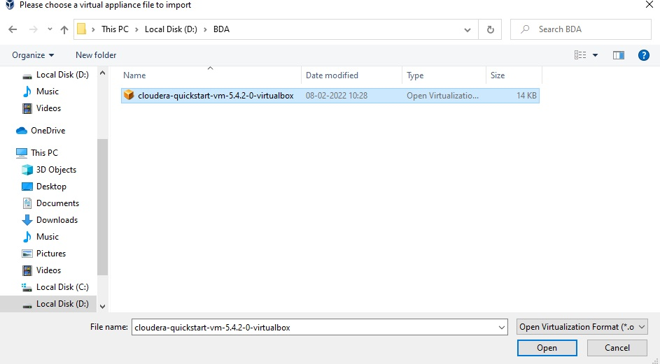

Step 7: Select Quick Start and Launch Cloudera

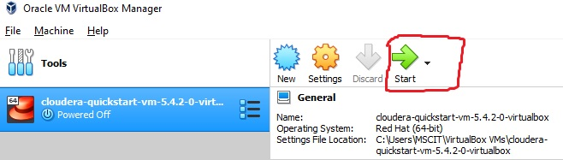

Output:

